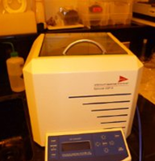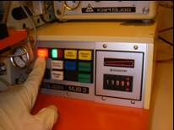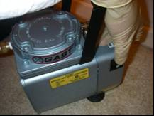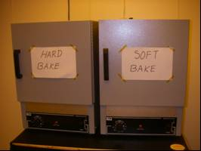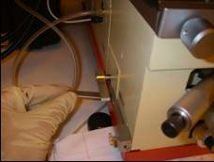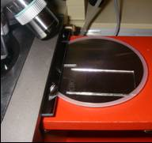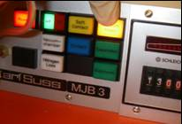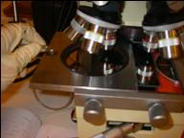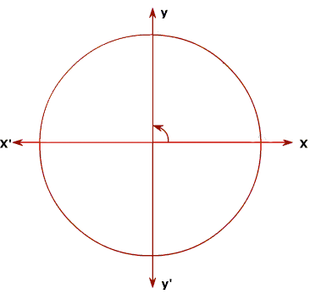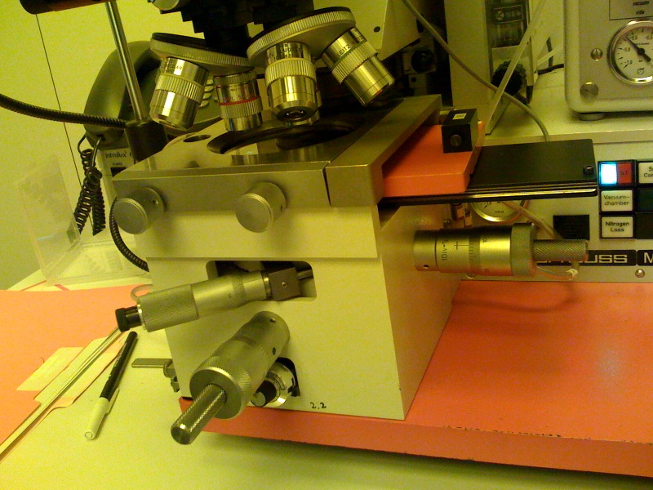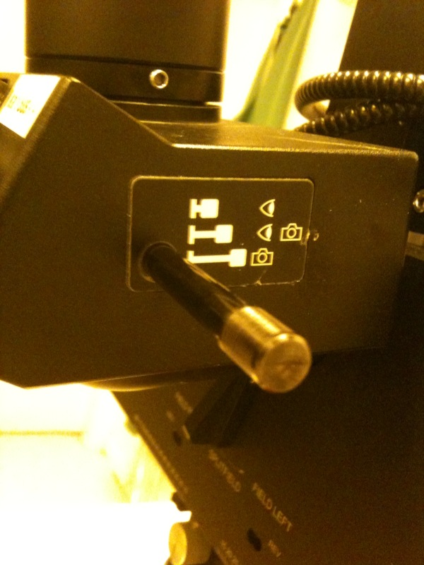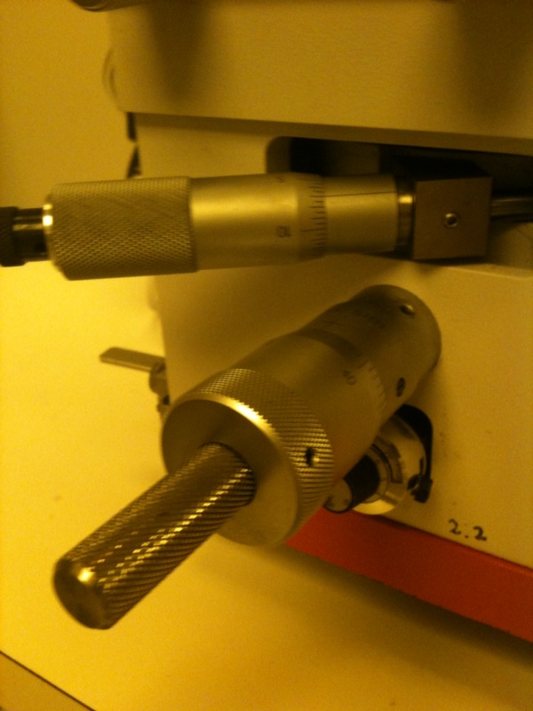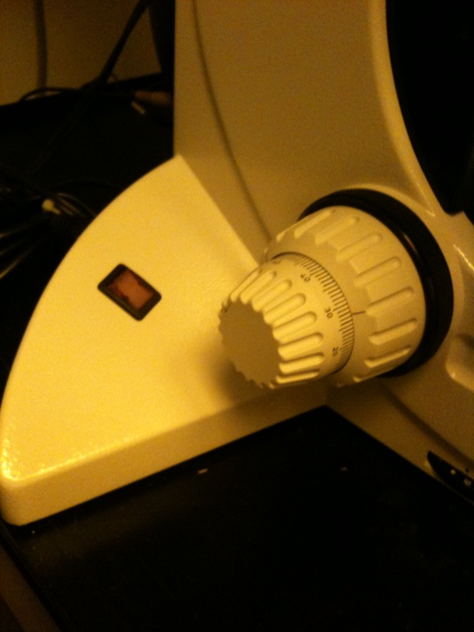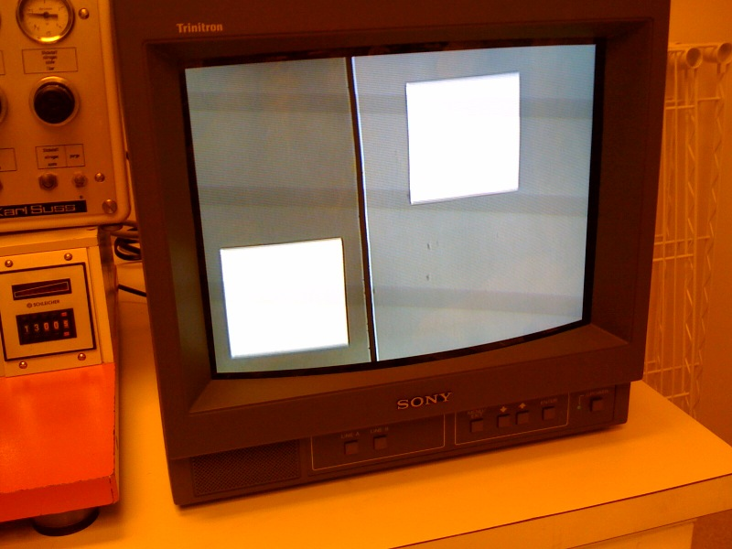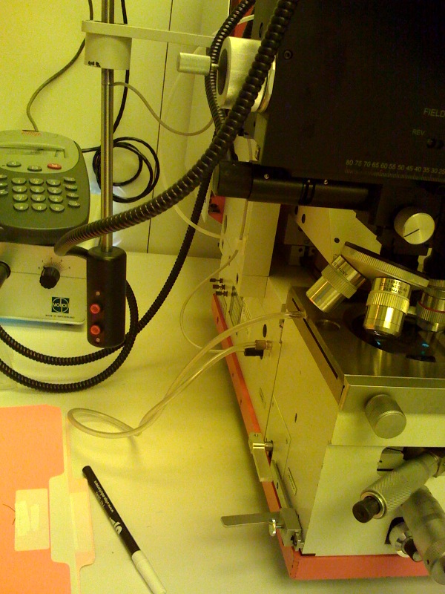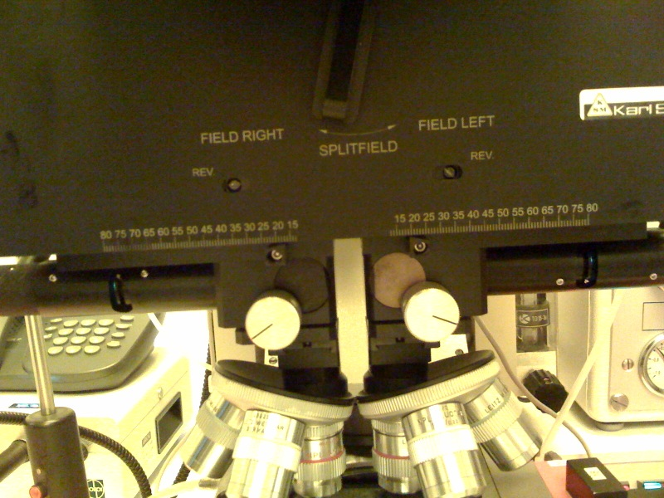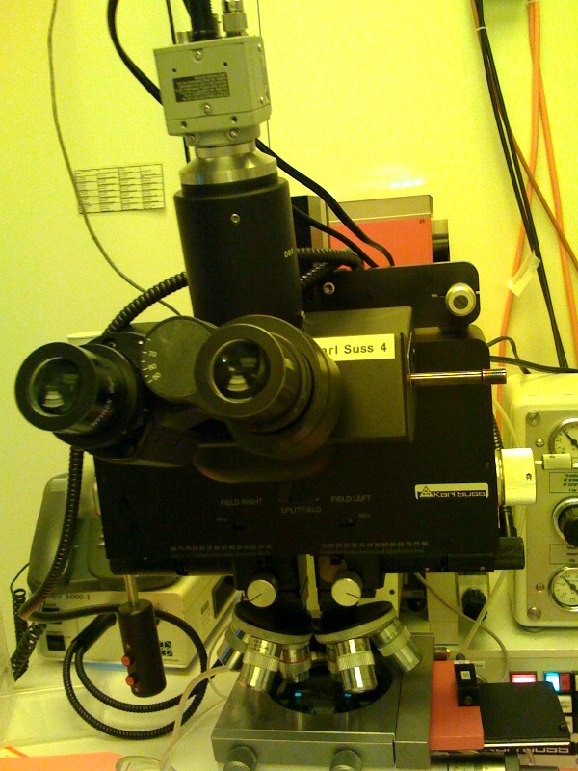

*Standard Operating Procedure*

5

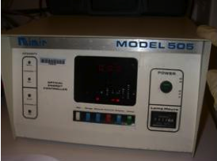

Turn on Model 505 wait 2-4 min. (very important to wait)

Click the lamp on.

NOTE: If it makes a repetitive spark or beeping noise, wait for a longer time

4

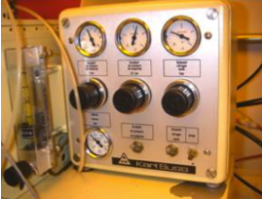

Go to the mask aligner table

Open the Nitrogen valves

Turn on the Air pressure & Nitrogen by   
clicking the two switches up

Turn on MJD3 by pressing the red “power” button

3

Turn on vacuum pump for Spinner:

* + Plug into outlet
  + Turn on with switch
  + Open the nitrogen valve

Turn on the Spinner

2

**In the Lithography Bay**

Turn on the Hot Plate and set to 110°C

Turn on the Soft Bake oven and set to 90°C

Take out photoresist from the refrigerator (need it at room temp)

POSITIVE RESIST: AZ4110 or AZ5214 E without flood exposure

NEGATIVE RESIST: AZNL05510 or AZ5214 E with flood exposure

**Gas and Vacuum Systems**

1. Connect the orange plug to turn on the vacuum pump
2. Turn the air compressor to “Auto”
3. Open the compressor valve in parallel to allow the air to flow
4. Turn on the Nitrogen Gas tank. Pressure should read higher than 100

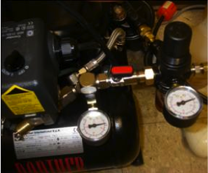

1

**Lithography**

**continued…**

Figure A

c

d

a

b

θ

**Exposure**

9

**Aligning Mask and Wafer**

8

* Take out the sample and place it on the tray of the mask aligner. Let it cool down for a minute
* Insert the mask tray back into the mask aligner

*If you are aligning mask to a design, use step 9 for alignment instructions otherwise continue and skip step 9.*

* On the bottom left side of the mask aligner there are two levers
  + Slowly move the horizontal stick from front to back (separation)
  + Slowly turn the rod, you will hear a click and check for the indicator   
     Contact to be ON.
* Click on exposure and wait (Don’t look at the UV light)
* Slowly turn the rod, you will hear the click and check that the indicator light of the Contact button turns off
* Slowly move the horizontal stick from back to front
* Slide the mask positioner to take out your sample
* (**Only for 5214 negative**) postbake the sample (PB) for 90 sec on the hot plate at 110°C, cool down, and flood exposure (exposure to UV without using the mask) for 99 sec

**Mask Installation**

* Loosen the screws in the front of the mask aligner.
* Take out the mask positioner
* Place the mask over the mask positioner   
   (*check that the printed side is facing up and the pattern is exposed   
   through the positioner*)
* Press the vacuum button mask to hold the mask in place
* Place the mask position back into the mask aligner
* Tighten the screws in the front of the mask aligner
* Set up the desired exposure (usual time will be 13.00s)

7

**Spin Coating**

* Take your sample to the spinner and place your sample in the middle centering  
   it with tweezers.
* Push the button *Vacuum press* and *Control*
* Set Speed I to 600-800 rpm for 12 sec (bottom left knob)
* Set Speed II at 3000 rpm for 30 sec (bottom right knob)
* Prepare one plastic pipette (2-3mL) full of PR
* Press start and empty the contents of the pipette in the duration of   
   the first stage (Speed I)
* Press vacuum so the vacuum seal releases the sample.
* Take the sample to the soft bake oven and leave it there   
   for 15 min at 90°C.

6

* When aligning a wafer with a pattern to a mask, the contact lever must not be clicked all the way to allow movement without damaging the wafer
* ALIGNING THE WAFER: (Fig A)
  1. Mask aligner tray – slide out to place wafer on
  2. Moves the wafer in the X-axis direction
  3. Moves the wafer in the y-axis direction
  4. Rotates the wafer in θ direction

c

b

a

a

b

Figure C

* + - * MOVING THE MICROSCOPE: (Fig B)
      1. Push to release the X-axis and move the lever
      2. Push to release the Y-axis and move the lever
      3. Turn the left knob to move the position of the left objective
      4. Turn the right knob to move the position of the right objective
* A good technique to align the wafer to the mask is to check all the 4 corners of the mask and design are aligned and check a row and column to make sure the wafer consistently aligned
* Once it looks good on the screen, click the contact all the way over to allow the wafer to contact the mask
* Go back to step 8 and finish the exposure procedure

d

* USING THE MONITOR:
  1. Pull and Push the rod to get different settings
     + Lens Only
     + Lens and Monitor
     + Monitor Only
  2. Turn on the monitor by pushing “Power” and “A Line”
  3. Split Field allows you to view the right or left objectives

Figure B

c

b

a

* + - * Focusing the image: (Fig C)
  1. Coarse knob
  2. Fine knob

10

* In a beaker, pour developer solution   
   (300MIF for negative and AZ400 for positive)
* Submerge the sample using tweezers to remove the non cured PR.   
   (Time is 25 seconds to 4 minutes depending in the postbaking step)
* Transfer the sample to a beaker with DI water   
   (preferably put it under running water)
* Check the pattern in the Leica microscope.
* To turn it on, follow the next sequence:
  + Turn down the light (power 0) and then turn on the microscope switch
  + Slowly increase the light power to the desired intensity
  + Adjust focus by moving the large knob (coarse and fine)
* Check the pattern. If you observe PR residues, repeat the developing procedure

**Etching and Viewing**

**Shut Down Check List**

Turn off microscope

Turn off spinner and clean it

Dispose of all the chemicals

Rinse thoroughly all beakers and let them air dry

Turn off Soft bake oven

Turn off Hot plate

Disconnect spinner vacuum pump

Place mask back into it’s case

Click the lamp button in Model 505 machine off

Turn off model 505 machine

Turn off power in MJB3 machine

Turn off lights and fans in hood and room

Check that all water faucets are closed

Check that all Nitrogen valves are closed

Close Nitrogen gas

Turn off compressor, and disconnect the vacuum pump